Matrix Representation of 3D Transformations

2D transformations can be represented by 3 x 3 matrices using homogenous coordinates, so

3D transformations can be represented by 4 x 4 matrices, providing we use homogeneous coordinate representations of points in 2 space as well.

Thus instead of representing a point as (x , y ,z) , we represent if as (x , y , z, H), where two these quadruples represent the same point it one is a non zero multiple of the other the quadruple (0,0,0,0) is not allowed.

A standard representation of a point (x , y ,z ,H) with H not zero is given by
(x/H , y/H, z/H, 1).

Transforming the point to this form is called homogenizing.

Translation:
A point is translated from position P=(x,y,z) to position P’ = (x’,y’,z’) with the matrix operation

x’ 1 0 0 t_{x} x
y’ = 0 1 0 t_{y} . y
z’ 0 0 1 t_{z} z
1 0 0 0 1 1

or P’ = T.P
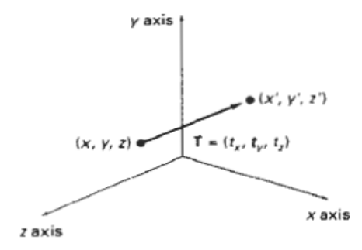

Parameters t_{x} , t_{y} ,t_{z} specify translation distances for the coordinate directions x ,y and z.

This matrix representation is equivalent to three equations:
x’ = x + t_{x} y’ = y + t_{y} z’ = z + t_{z}

Scaling:
Scaling changes size of an object and repositions the object relative to the coordinate origin.

If transformation parameters are not all equal then figure gets distorted

So we can preserve the original shape of an object with uniform scaling(s_{x=} s_{y=} s_{z})

Matrix expression for scaling transformation of a position P = (x,y,z) relative to the coordinate origin can be written as :

x’ s_{x} 0 0 0 x
y’ 0 s_{y} 0 0 . y
z’ = 0 0 s_{z} 0 z
1 0 0 0 1 1

or P’ = S . P
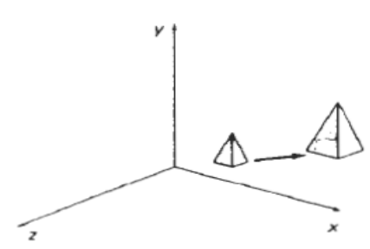

Scaling with respect to a selected fixed point
(x_{f ,} y_{f ,} z_{f}) can be represented with:

i. Translate fixed point to the origin
ii. Scale object relative to the coordinate origin
iii. Translate fixed point back to its original position

or T(x_{f ,} y_{f ,} z_{f}). S(s_{x ,} s_{y ,} s_{z}).T(-x_{f ,} -y_{f ,} -z_{f})
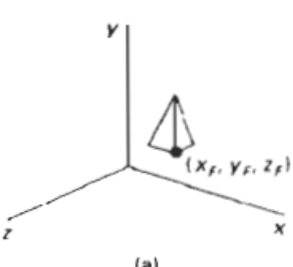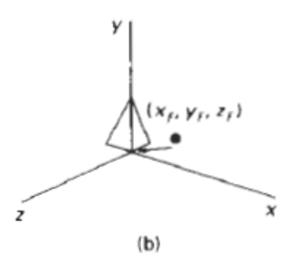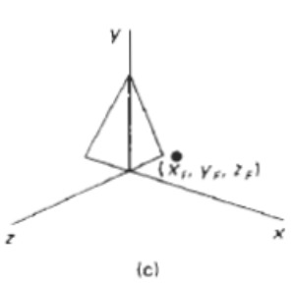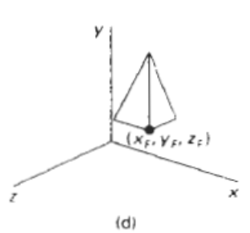

Reflection:
Reflections with respect to a plane are equivalent to 180* rotations in four dimensional space.

1 0 0 0
RFz = 0 1 0 0
0 0 -1 0
0 0 0 1
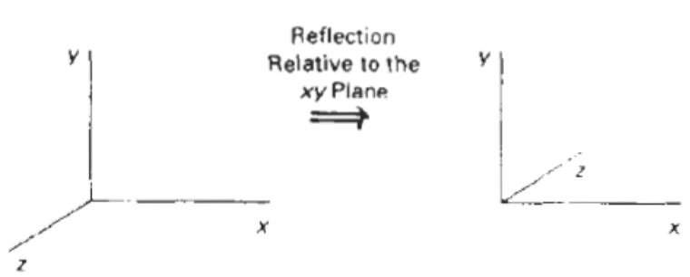

This transformation changes the sign of the z coordinates, leaving the x and y coordinate
values unchanged.

Transformation matrices for inverting x and y values are defined similarly, as reflections relative to the yz plane and xz plane.

Shearing:
Shearing transformations are used to modify object shapes.
E.g. shears relative to the z axis:

1 0 a 0
SHz = 0 1 b 0
0 0 1 0
0 0 0 1
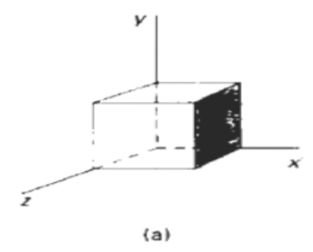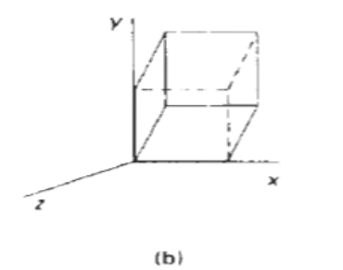

where parameters a and b assume any real values.

It alters the x and y coordinate values by an amount that is proportional to the z value while leaving the z coordinate unchanged.

Shearing matrices for x and y axis can be obtained similarly.
Rotation:
Designate the axis of rotation about which the object is to be rotated and the amount of angular rotation .
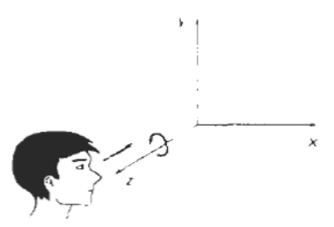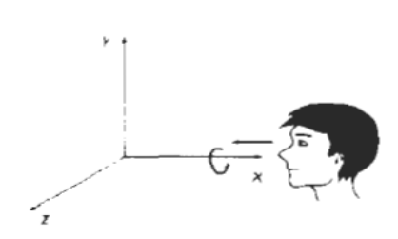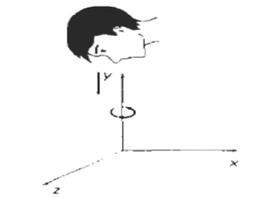

Axes that are parallel to the coordinate axes are easy to handle.

Coordinate axes Rotations:
2D z-axis rotation equations are easily extended to 3D:
x’ = xcosθ - ysinθ y’ = xsinθ + ycosθ z’ = z …………(i)

3D z-axis rotation equations are expressed in homogenous coordinate form as

x’ cosθ -sinθ 0 0 x
y’ = sinθ cosθ 0 0 . y
z’ 0 0 1 0 z
1 0 0 0 1 1

or,
P’ = Rz (θ) . P
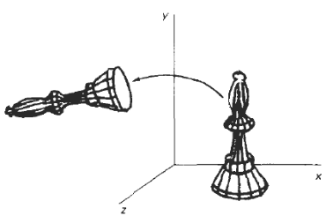

Cyclic permutation of the coordinate parameters x , y and z are used to get transformation equations for rotations about the other two coordinates
x → y → z → so,
substituting permutations in (i) for an x axis rotation we get,
y’ = ycosθ - zsinθ z’ = ysinθ + zcosθ x’ = x

3D x-axis rotation equations in homogenous coordinate form as

x’ 1 0 0 0 x
y’ = 0 cosθ -sinθ 0 . y
z’ 0 sinθ cosθ 0 z
1 0 0 0 1 1

or,
P’ = Rx (θ) . P
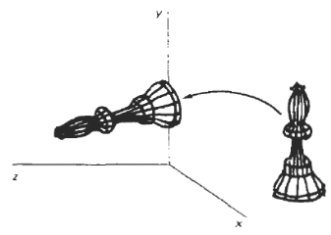

substituting permutations in (i) for a y axis rotation we get,
z’ = zcosθ - xsinθ x’ = zsinθ + xcosθ y’ = y
3D y-axis rotation equations are expressed in homogenous coordinate form as

x’ cosθ 0 sinθ 0 x
y’ = 0 1 0 0 . y
z’ -sinθ 0 cosθ 0 z
1 0 0 0 1 1

or, P’ = Ry (θ) . P
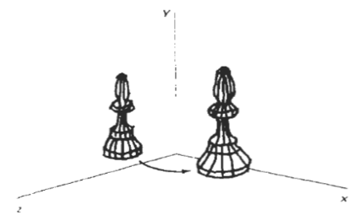

Rotation about an axis parallel to one of the coordinate axes :
Steps:
i. Translate object so that rotation axis coincides with the parallel coordinate axis.
ii. Perform specified rotation about that axis
iii. Translate object back to it’s original position.
ie. P’ = T⁻¹ . R_{x}(θ) . T . P
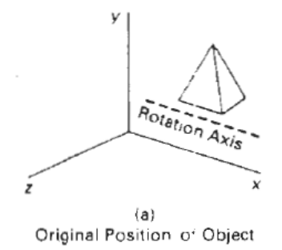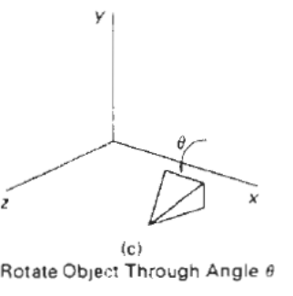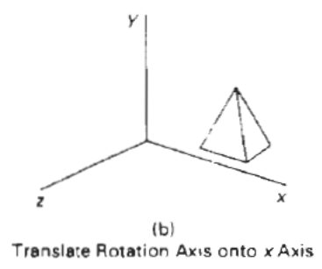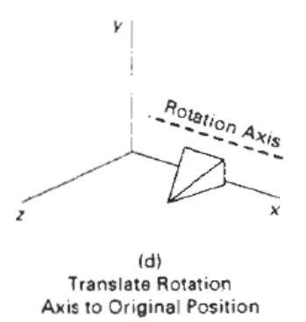

Rotation about an arbitrary axis :
An arbitrary axis in space passing thru point (x₀, y₀, z₀) with direction cosines (c_{x}, c_{y}, c_{z})
Steps required for rotation about this axis by some angle 0 are:
i. Translate so that point(x₀, y₀, z₀) is at the origin of the coordinate system
ii. Perform rotations to make axis of rotation coincident with the z axis
iii.Rotate about the z axis by the angle θ.
iv.Perform the inverse of the combined rotation transformation
v. Perform the inverse of the translation.
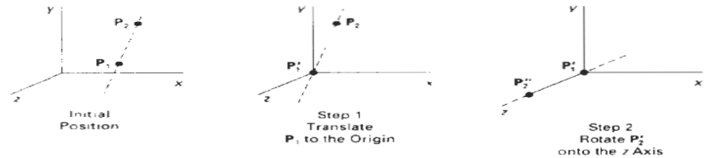

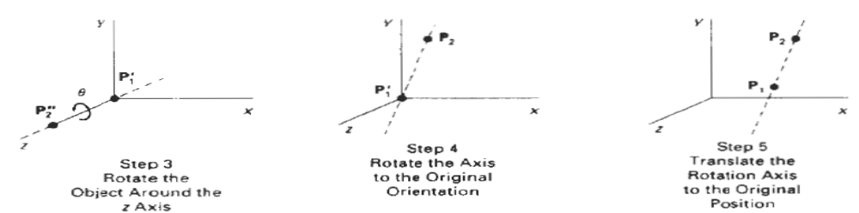
Making an arbitrary axis passing thru origin coincident with one of the coordinate axes requires two successive rotations about the other two coordinate axes.

To make arbitrary rotation axis coincident with
the rotation angle, about the x axis used to place the
arbitrary axis in the xz plane, first project the unit
vector along the axis onto the yz plane.

y and z components of the projected vector are
c_{y} and c_{z} (the direction cosines), so from fig.

d = c_{y}² ₊ c_{z}²
so,
cos = c_{z}/d sin = c_{y}/d
so, transformation matrix for rotation about x axis is:

1 0 0 0 1 0 0 0
Rx( ) = 0 cos -sin 0 0 c_{z}/d -c_{y}/d 0
0 sin cos 0 0 c_{y}/d c_{z}/d 0
0 0 0 1 0 0 0 1

After rotation about the x axis into
the xz plane, the z component of the
unit vector is d, and x component is
c_{x} (the direction cosines)

Rotation angle about the y axis
required to make the arbitrary axis
coincident with the z axis is
cos = d sin = c_{x}

so, transformation matrix for rotation about y axis is:

cosθ 0 sinθ 0 d 0 -c_{x} 0
Ry(θ) = 0 1 0 0 0 1 0 0
sinθ 0 cos(θ) 0 c_{x} 0 d 0
0 0 0 1 0 0 0 1

required translation matrix is

1 0 0 x₀
0 1 0 y₀
T = 0 0 1 z₀
0 0 0 1
finally,
rotation about the arbitrary axis is given by z axis rotation matrix,

cosθ -sinθ 0 0
R_{z}( ) = sinθ cosθ 0 0
0 0 1 0
0 0 0 1

so the transformation matrix for rotation about an arbitrary axis then can be expressed as the composition of these seven individual transformations:
R(θ) = T⁻¹ . R_{x}⁻¹ (θ) . R_{y}⁻¹ (θ) . R_{z} (θ) . R_{y}(θ) . R_{x} (θ) . T

If the values of direction cosines are not known (c_{x}, c_{y}, c_{z}) then they can be obtained knowing a second point on the axis (x₁, y₁, z₁) by normalizing the vector from the first to second point.
Vector along the axis from (x₀, y₀, z₀) to (x₁, y₁, z₁) is
[V] = [(x₁ - x₀ ) (y₁ - y₀) (z₁ - z₀)]
Normalized ,it yields the direction cosines,

[(x₁ - x₀ ) (y₁ - y₀) (z₁ - z₀)]
[c_{x} c_{y} c_{z}] = -------------------------------------
[(x₁ - x₀ )² + (y₁ - y₀) ² + (z₁ - z₀) ²] ½

Reflection thru an arbitrary plane :
General reflection matrices cause reflection thru x = 0 y = 0 z = 0 coordinate planes respectively.

Often it is necessary to reflect an object thru a plane other than one of these.Which is obtained with the help of a series of transformations (composition).

- translate a known point P that lies in the reflection plane to the origin of the coordinate system
- rotate the normal vector to the reflection plane at the origin until it is coincident with the z axis
this makes the reflection plane the z = 0 coordinate plane

- after applying the above transformation to the object reflect the object thru the z = 0 coordinate plane.
i.e.
1 0 0 0
RFz = 0 1 0 0
0 0 -1 0
0 0 0 1

- Perform the inverse transformation to those given above to achieve the desired result.
So the general transformation matrix is:
M(θ) = T⁻¹ . R_{x}⁻¹ (θ ) . R_{y}⁻¹ (θ ) . Rflct_{z} (θ ) . R_{y}(θ) . R_{x} (θ ) . T
NOTE:
- See class notes for rotation about arbitrary axis and rotation about arbitrary plane

